605.681.82.FA19 Principles of Enterprise Web Development

Markham Shofner – Module 3 Homework – Java Portion

Main Class Name: ProductInt.java

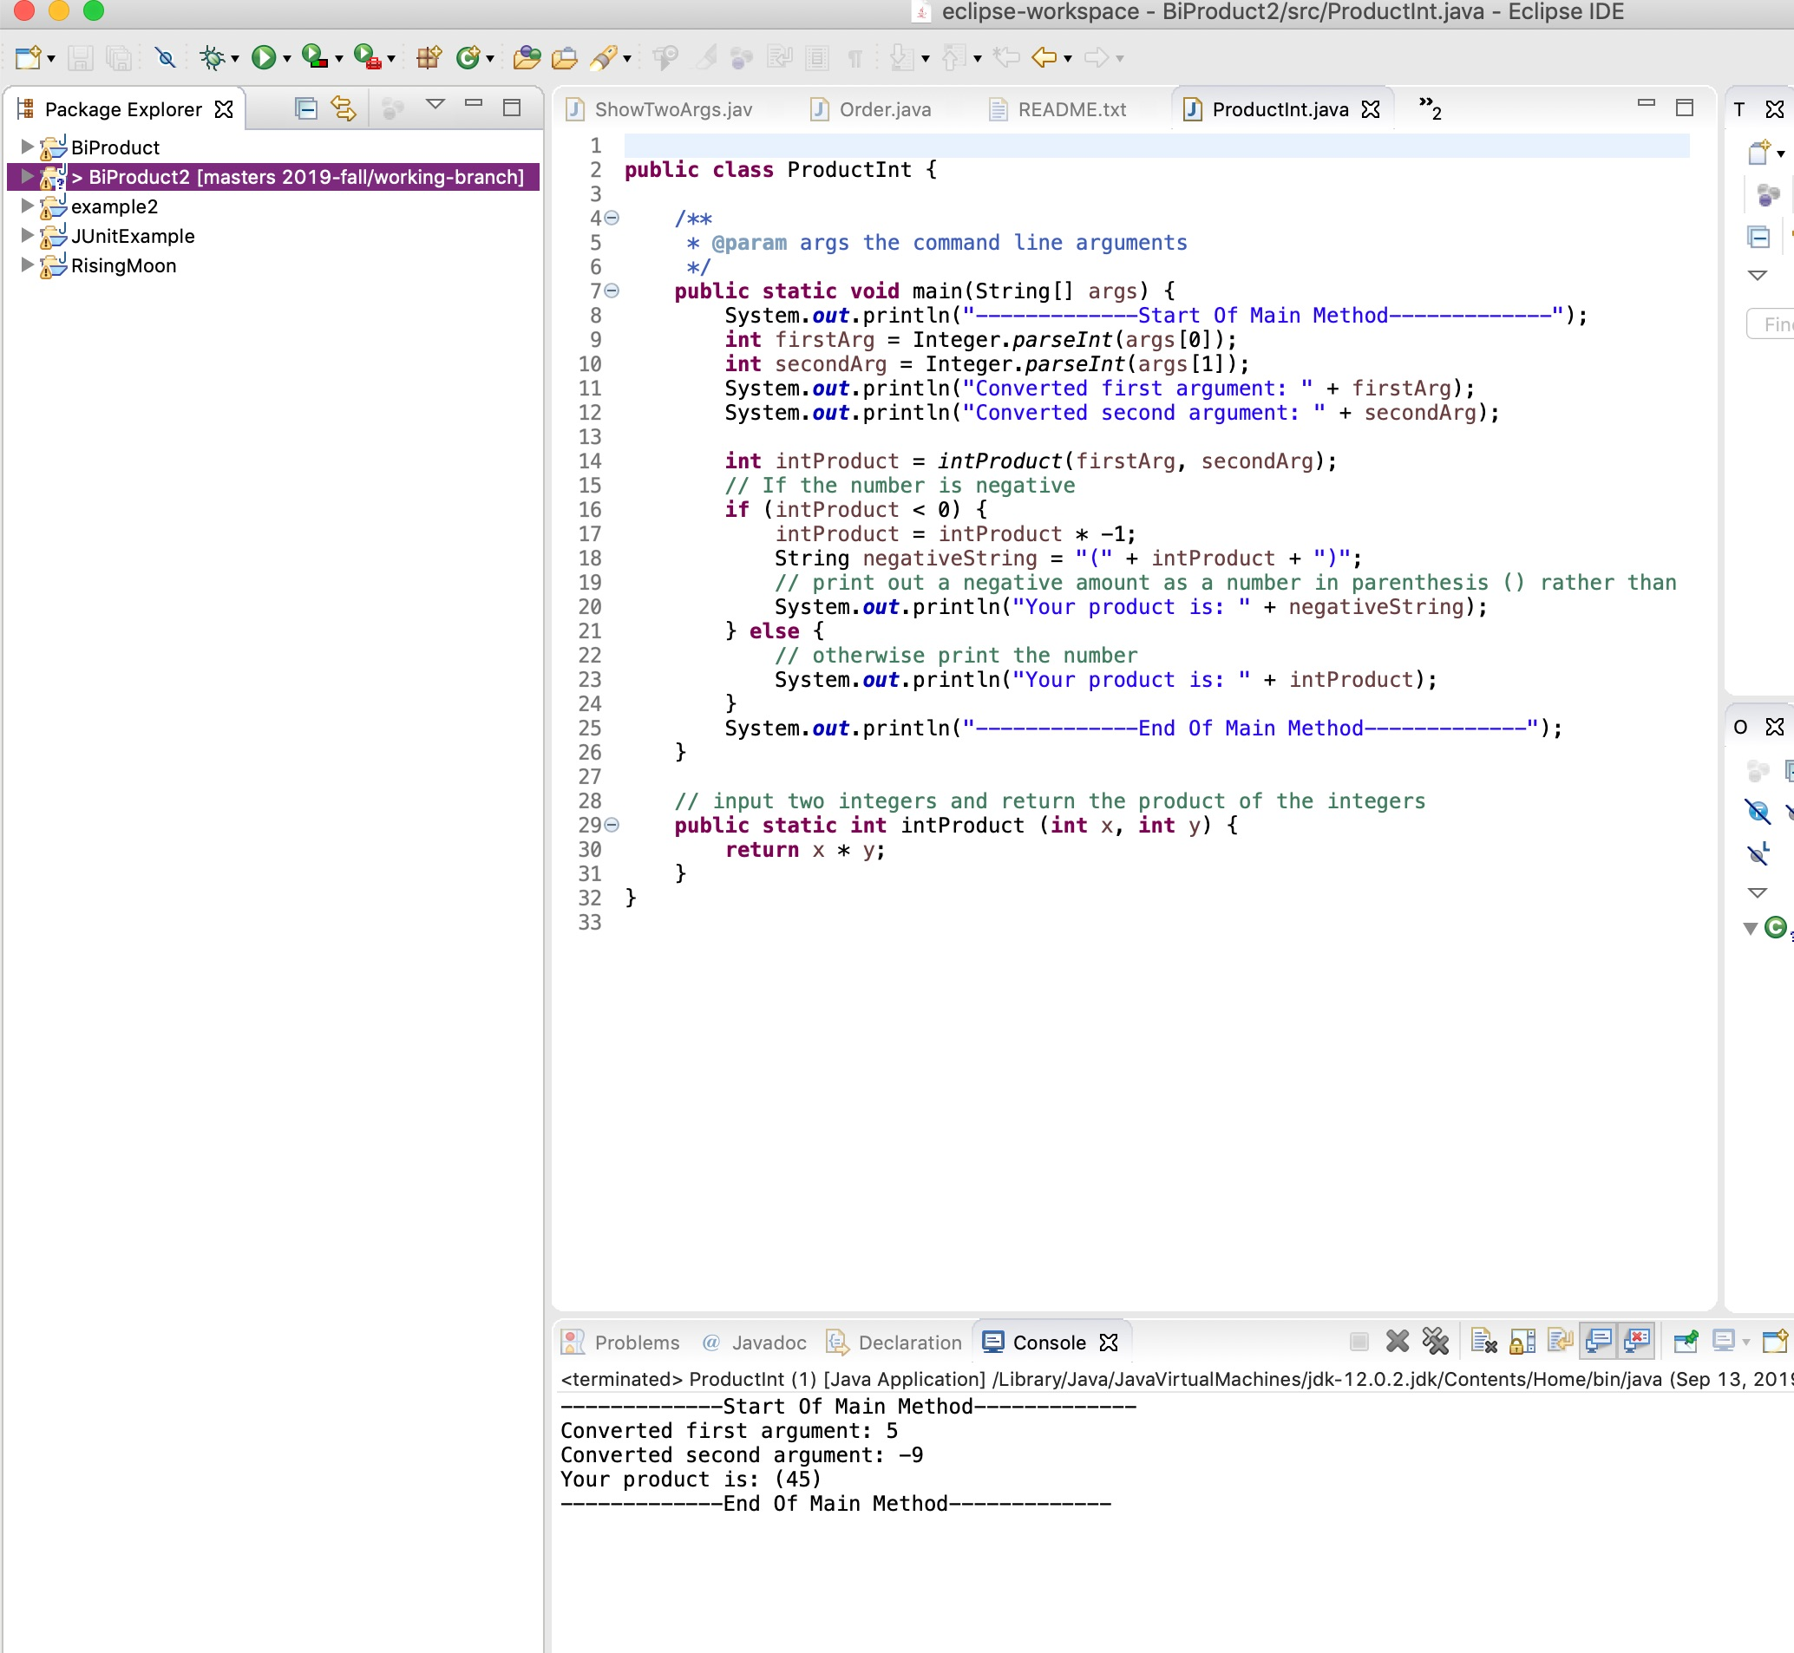

*Figure 1: Working Program*